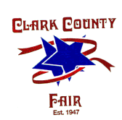
Clark County Fair Dates July 20-27, 2018

Company Name

Contact Name

Product

Email Address

Address

Phone

Please describe your intended display. Include a list of products to be exhibited and/or sold, a description of the display layout and indicated special features. (Note: No balloons or stickers permitted)
List all items to be given away

BOOTH SIZE/COST: (Non-Refundable) 10x10 = $300.00 (Do NOT send money at this time)

PLEASE COMPLETE AND RETURN TO: Clark County Fair
4401 South Charleston Pike
Springfield, OH 45502
937-323-3090
EMAIL: bbarger@clarkcoag.com

