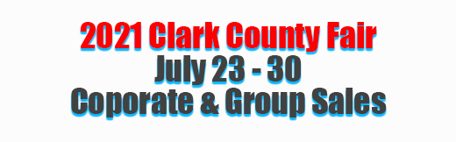

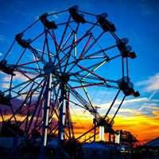
Are you looking for a great way to reward your employees for all their hard work? How about an outing at the 2021 Clark County Fair! We can supply a tent for your company’s exclusive use for several hours or all day. Want to
supply a meal? We will cater either fun fair food or any caterer that you prefer. Want rides wrist bands for the kids? No problem, we can supply you with the wrist bands. We will do whatever you desire to make sure you and your employees have a great family experience.
- Family Fun
- Use of Corporate Tent if needed
- Catering Available
- Entertainment if wanted
- Rides wristbands available
- Discount admission tickets
- Free parking
- Recognition on LED marquee sign
- PA announcement for your group

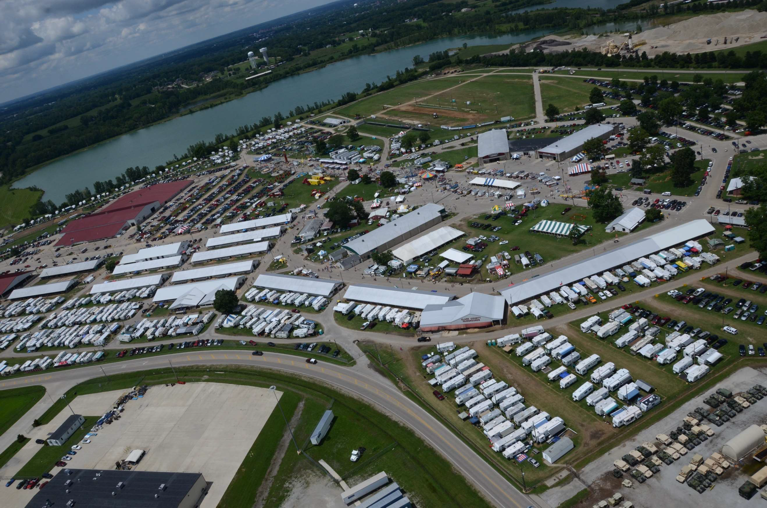
If you have any special requests or requirements, please let us know. We will do our best to meet your needs.
Discount admissions tickets are available with the purchase of 50 or more. Extra special pricing for 1000 or more.
Call: Dean Blair, Ex. Director 937.323.3090 office
937.926.2464 cell

