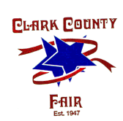
Clark County Fair Dates July 23-30, 2021

Company Name

Contact Name

Product

Email Address

Address

Phone

Please describe your intended display. Include a list of products to be exhibited and/or sold, a description of the display layout and indicated special features. (Note: No balloons or stickers permitted)
List all items to be given away

BOOTH SIZE/COST: (Non-Refundable) 10x10 = $300.00 (Do NOT send money at this time) Your application will be reviewed and contract will be emailed to you. Return the contract and send your payment at that time.

PLEASE COMPLETE AND RETURN TO: Clark County Fair
4401 South Charleston Pike
Springfield, OH 45502
937-323-3090
EMAIL: jamie@clarkcoag.com

