2025

BIG TENT

Friday, July 18, 7pm



Wyatt McCubbin

Saturday, July 19, 7pm



KATE HASTING

Sunday, July 20

CHRISTIAN MUSIC

Monday, July 21, 7pm

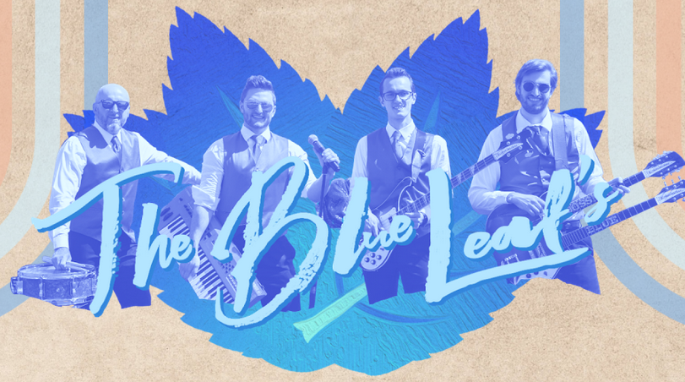

THE BLUE LEAFS

Tuesday, July 22. 7pm

4-H REVIEW

Wednesday, July 23, 7pm

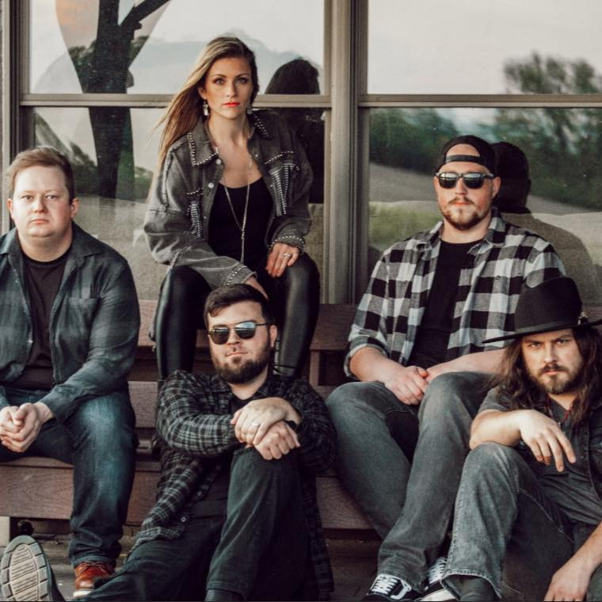

ALLISON ROAD

Thursday, July 24, 6:30pm

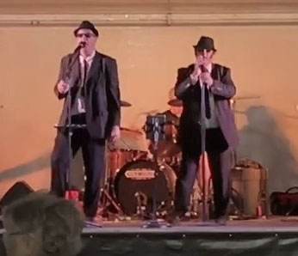

BLUES BROTHERS

Friday, July 25, 7pm

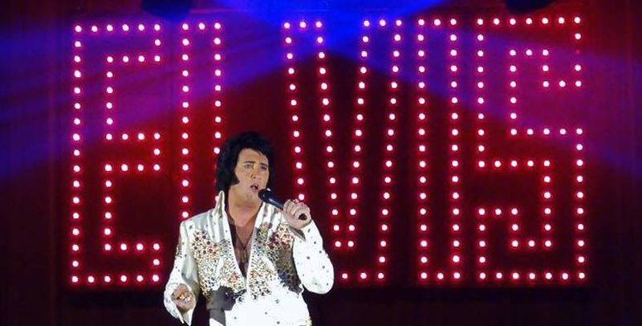

RYAN ROTH is ELVIS