2026 BIG TENT
Saturday, July 25, 7pm
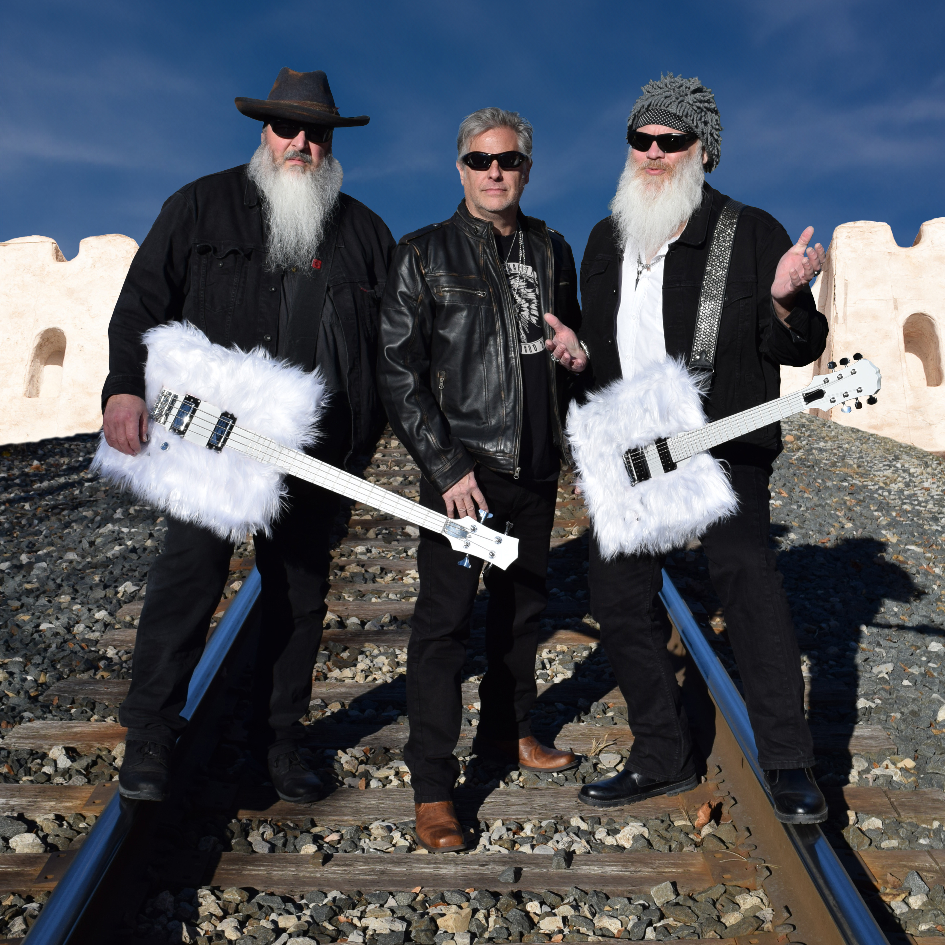
Thunderbeard (ZZ Top)

Sunday, July 26, 5 pm
First Christian & Medway Churches

Monday, July 27, 5 pm

Mary Kutter
Tuesday, July 28, 7pm
4-H Winners Review

Wednesday, July 29, 7pm
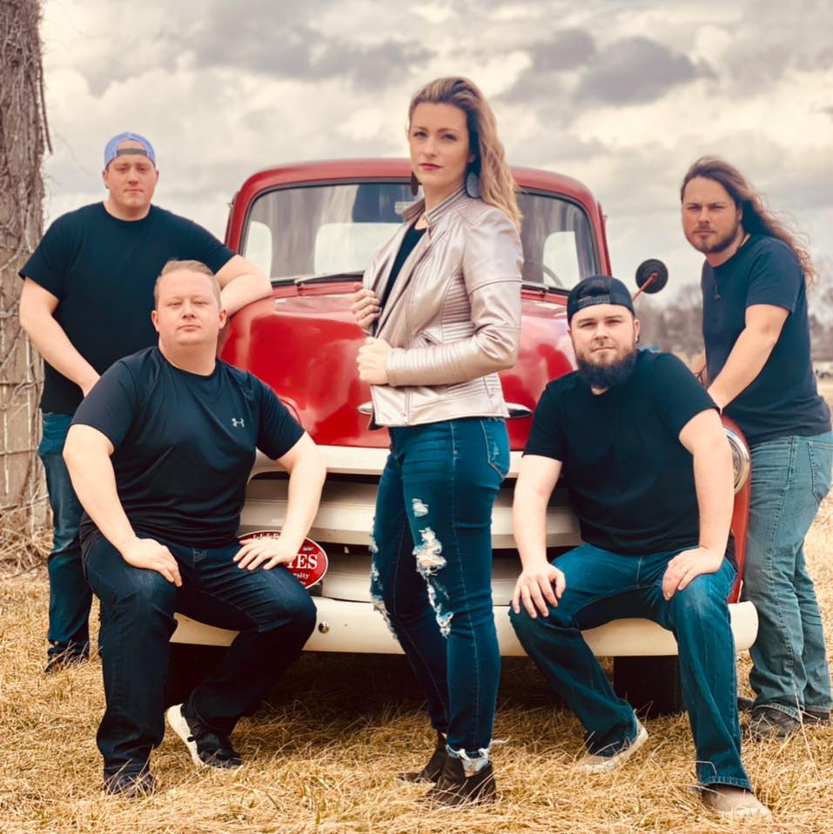
Allison Road

Thursday, July 30, 7pm

Hasting Music

