Midway Entertainment
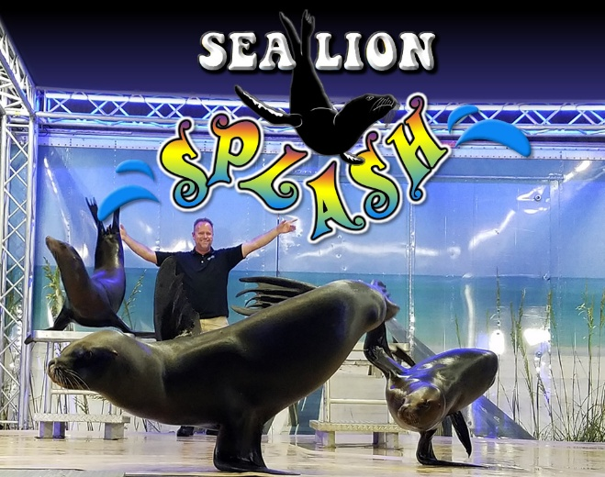
Sea Lion Splash
Fri 24th, Mon, Tue, Thu: 5pm, 9pm, 7pm
Sat, Sun, Wed: 3pm, 5pm, 7pm, 9pm
Fri 31st: 3pm, 6pm

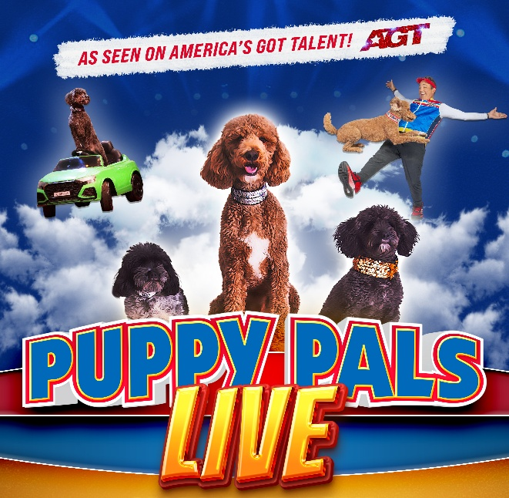
Puppy Pals Live
Fri 24th – Fri 31st: 4pm, 6pm, 8pm
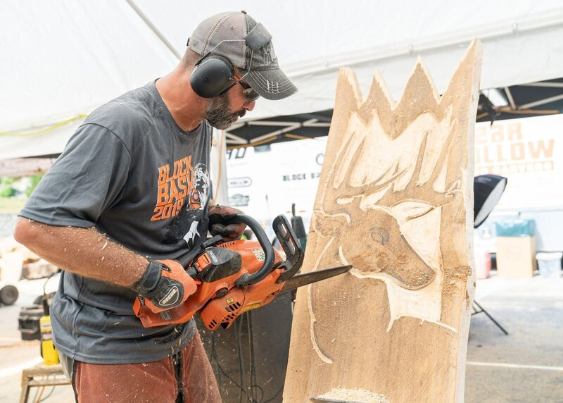
Bear Hollow Wood Carvers
Sat 25th – Fri 31st: 1pm, 4pm, 6pm, 8pm

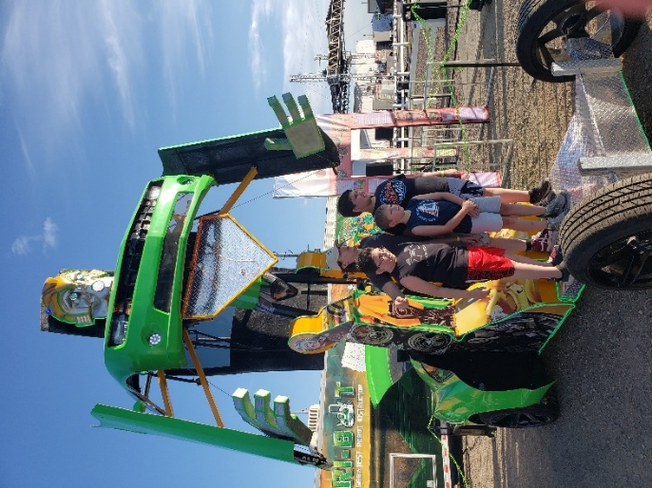
Agribot
Sponsored by Clark State
Mon 27th – Fri 31st: 3:30pm, 5:30pm, 7:30pm

